

**Vaccination is safe and side effects from a vaccine are usually minor and temporary,**

**Vaccination**

**Management System**

**Documentation of E-project**

|  |  |
| --- | --- |
| **STUDENT NAME** | STUDENT ID |
| **Muhammad Taimoor** | **Student 1403239** |
| **Abdul Basit** | **Student 1408470** |
| **Fareen Kareem** | **Student 1409261** |

Batch Code: **PR2-202208E**

Submitted to:  **Sir Ahmed Ali**

Project Instructor: **Sir Ahmed Ali**

CERTIFICATE

This is to certify that **Mr./Mrs**. Muhammad Taimoor, Abdul Basit,

Fareen Kareem.

Has Successfully Designed & Developed

Vaccination management system

submitted by**:**

Date Of Issue**:**

Authorized Signature**:**

Problem Statement

Problem statement is attached separately in a file “Vaccination

Management System”

Standards plan:

Every code block must have comments.

The logic of the program needs to be explained. Proper documentation

should be maintained.

Complete Project Report along with synopsis, code and documentation should

be prepared.

Documentation:

No project is complete without documentation. In fact, it is one of the most

important activities during the development of a project. The documentation

of an ideal project will be in the form of a project report comprising of the

following documents:

➢ Certificate of Completion.

➢ Table of Contents.

➢ Problem Definition.

➢ Customer Requirement Specification.

➢ Project Plan.

➢ E-R Diagrams.

➢ Algorithms.

➢ Interface Design Document.

➢ Task Sheet.

➢ Project Review and Monitoring Report.

➢ Unit Testing Check List.

➢ Final Check List.

**INTRODUCTION**

In the existing system, Vaccines are provided for infants and children under teenage by various aspects such as by attending school manually and there is a chance that some of the children’s and infants may miss the opportunity of getting vaccinated due to some mandatory reasons. Which leads to loss of life or gets affected by various diseases such as polio… etc.? This is a time delay process to

wait for each and every one all over the places.

Proposed Solution

We can change this manual system into e-vaccination system by collecting the info of infants, registered under website so that those who didn’t took vaccination can avail one more opportunity to save the life of their children. By this system a lot of man-hours can be saved and it is efficient too.

## Objectives of the project

The Objective of this program is to give a sample project to work on real life projects. These applications help you build a larger more robust application.

The objective is not to teach you the concepts but to provide you with a real-life scenario and help you create applications using the tools.

You can revise them before you start with the project.

It is very essential that a student has a clear understanding of the subject.

Kindly get back @ [eprojects@aptech.ac.in](mailto:eprojects@aptech.ac.in) in case of any doubts regarding the application or its objectives.

In the first phase all the faculties are requested to try out all the problems and then revert back if any problems are there. You can mail at [eprojects@aptech.ac.in](mailto:eprojects@aptech.ac.in)

**SOFTWARE USED**

## MICROSOFT VISUAL STUDIOS CODE

We have used VS Code a text editor for developing and designing this project

**XAMPP**

We used Xampp Web Server Solution.

## ADOBE PHOTOSHOP CC

We use Photoshop to design logos and pictures. Through this software we can easily utilize all the tools of graphics.

Admin Login Credentials & Details:

Database Name: managment

Admin Login Details:

Username: fatima

Password: fatima12

Making an appointment creates account for the patient

Flow Chart

LOGIN

Add hospital,

View hospital

ADMIN

New Appointment

Add Appointment

Approve Appointment

View Child Records

Child

Child details,

Next vaccine

Hospital details

LOGOUT

FEEDBACK

Hospital

Hospital

**SCREENSHOTS**

Index Page Coding:

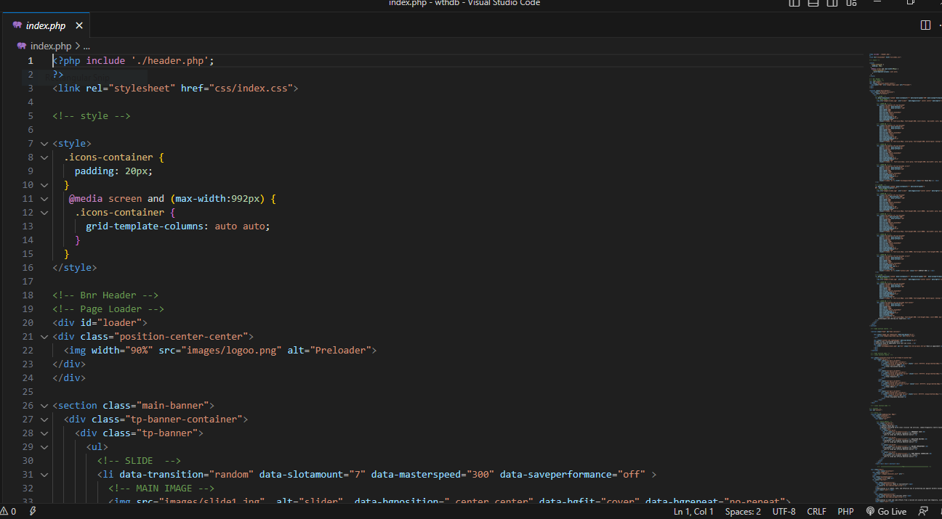

Header.php File Coding:

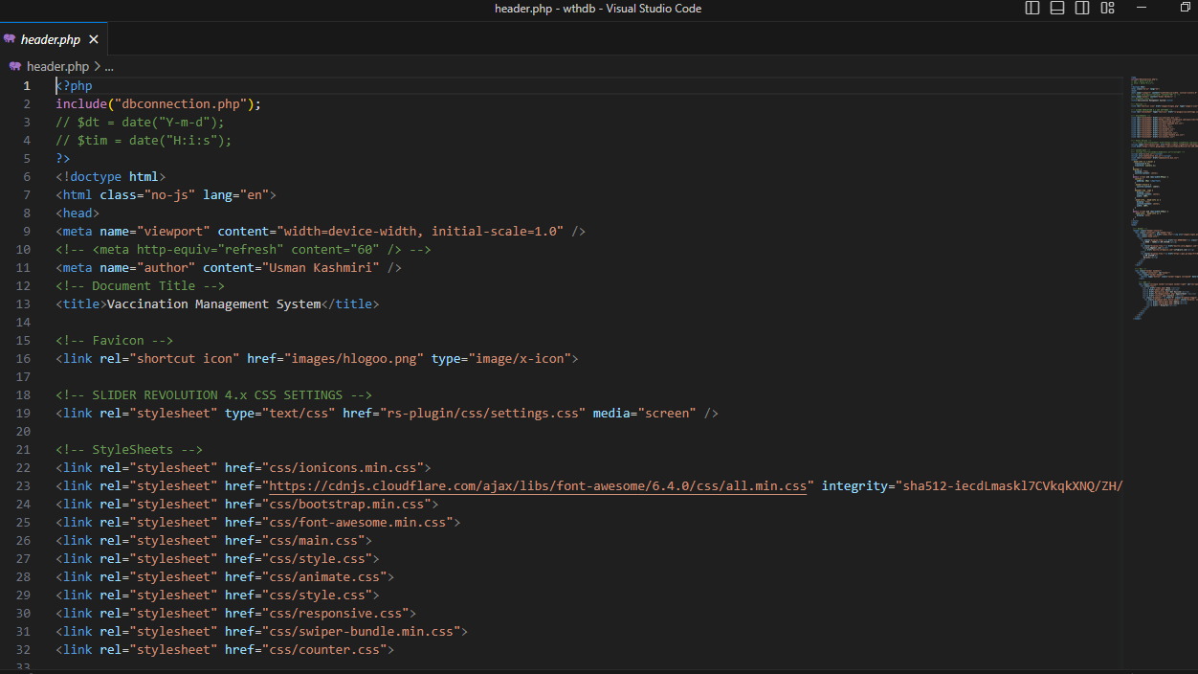

Recipes:

Footer.php File Coding:

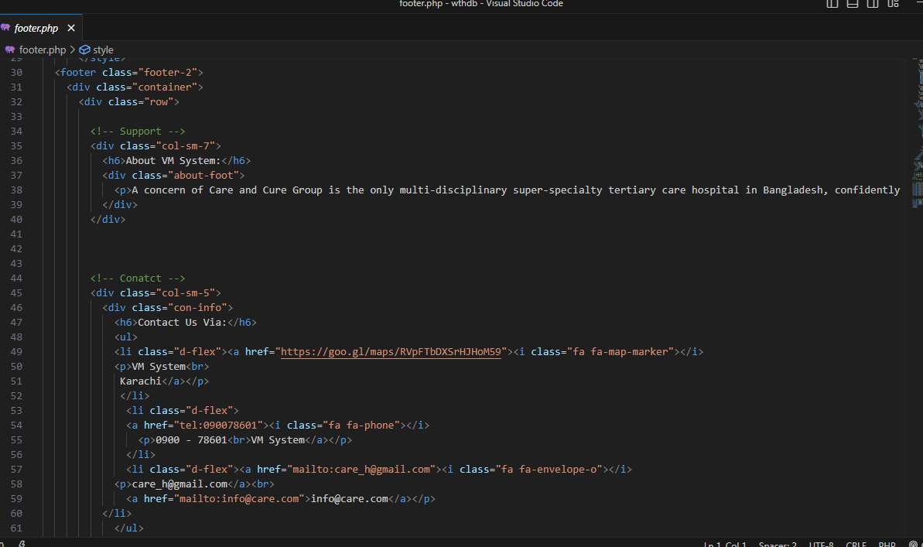

Google Recaptcha Integration on Login Forms:

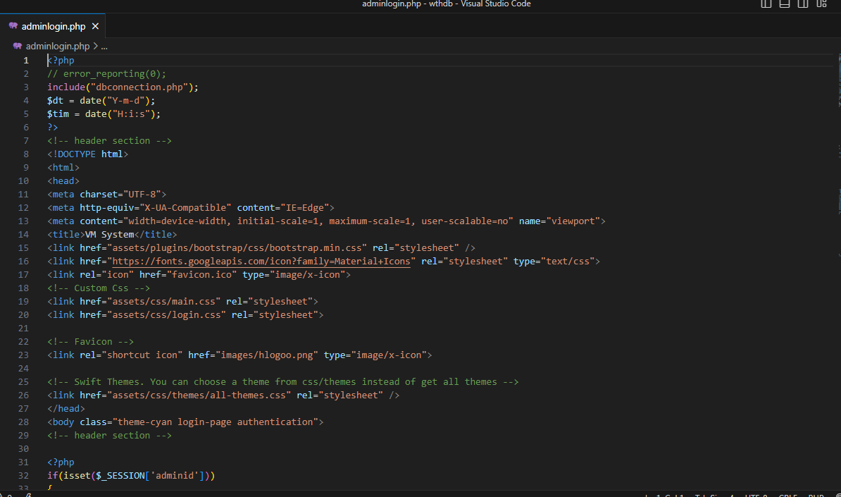

Entity Rational Diagrams (ERD) of Database:

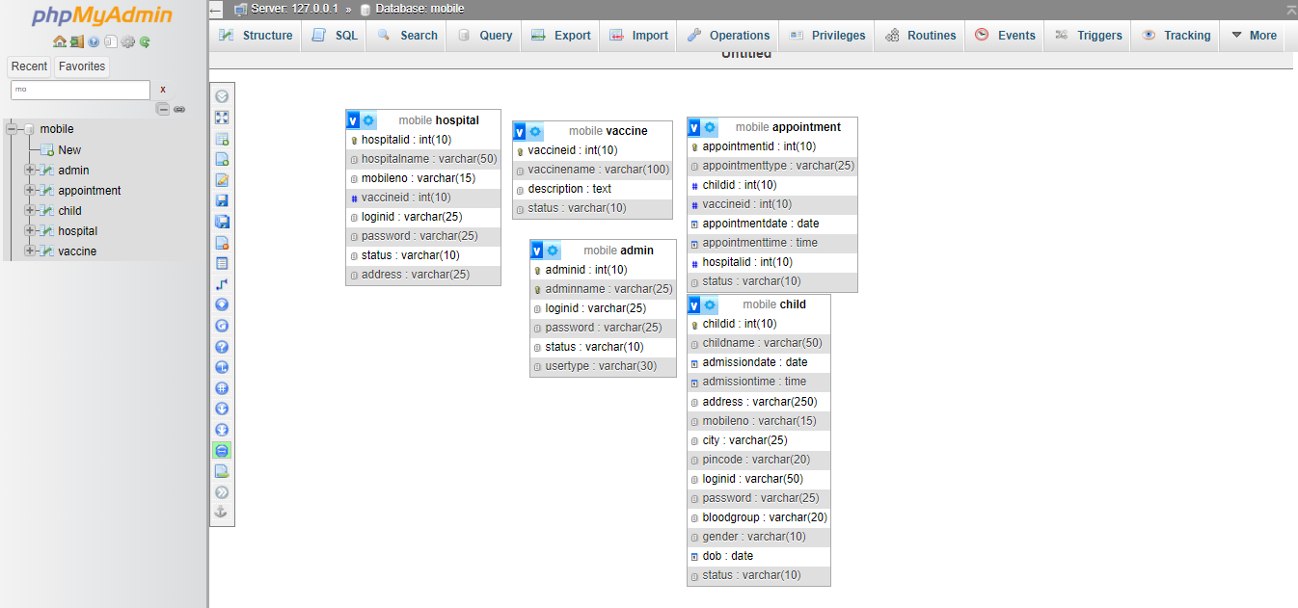

Preloaded:

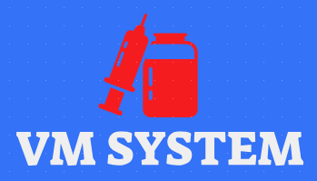

Landing Page:

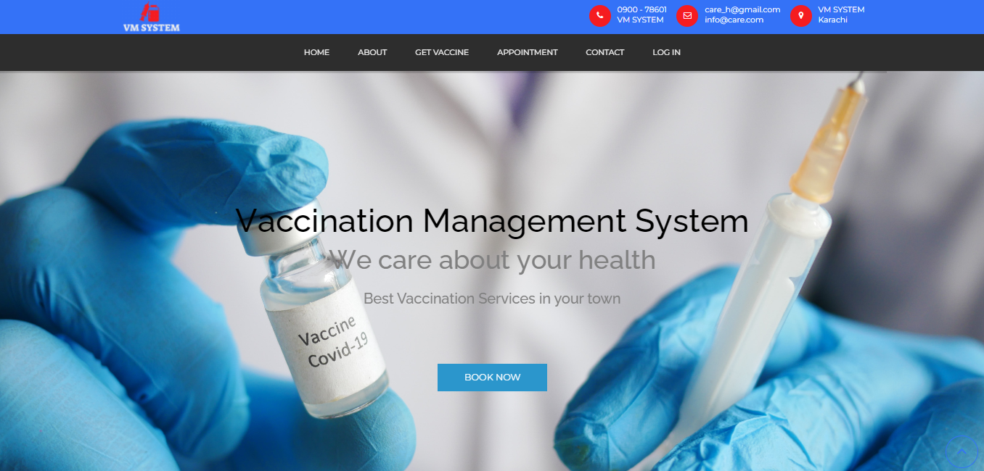

Footer:

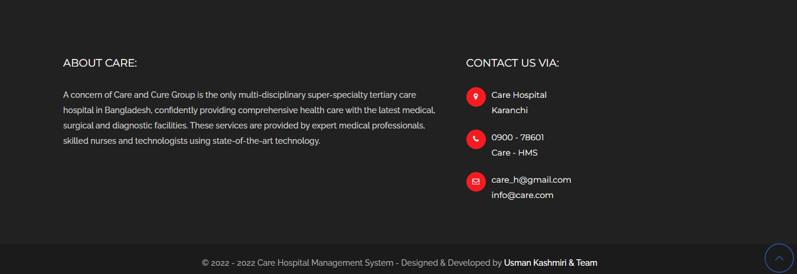

Book an Appointment:

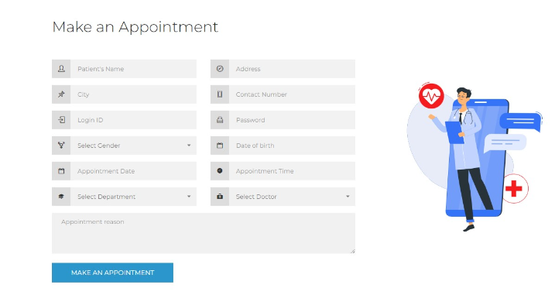

About Us Page:

About

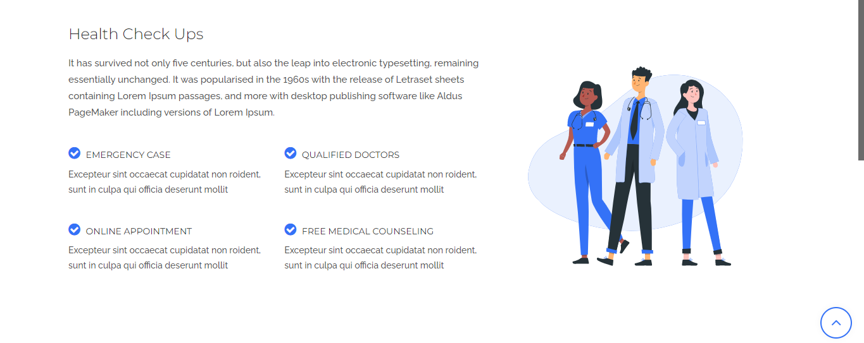

Contact Us Page:

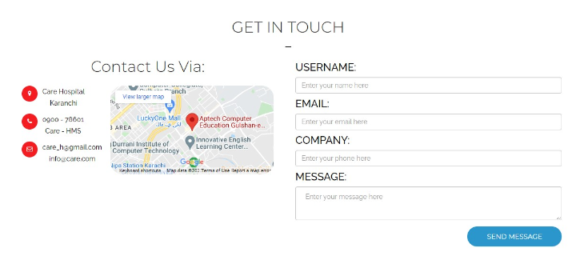

Login Page:

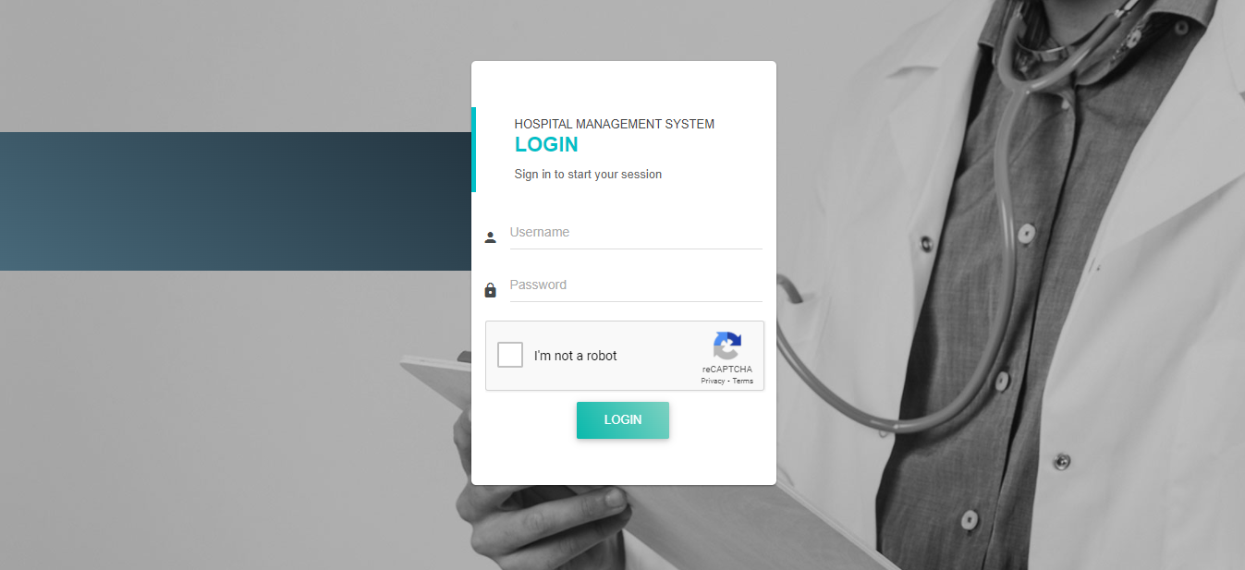

Admin Panel:

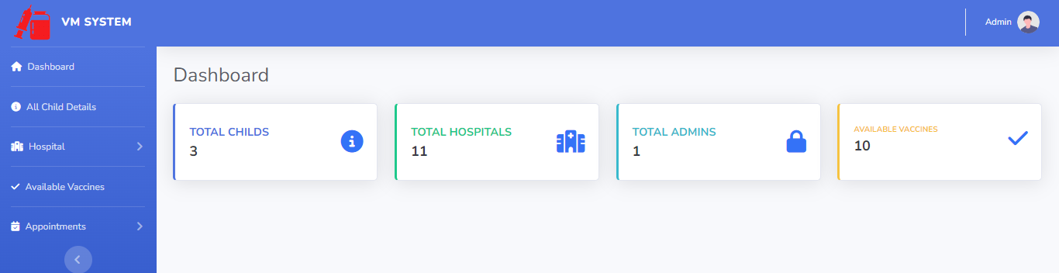

Child Admin Panel:

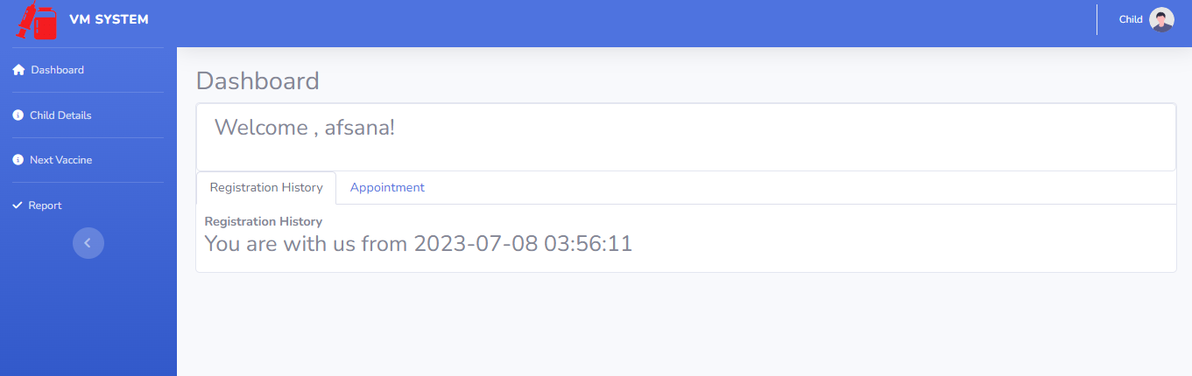

Hospital Admin Panel:

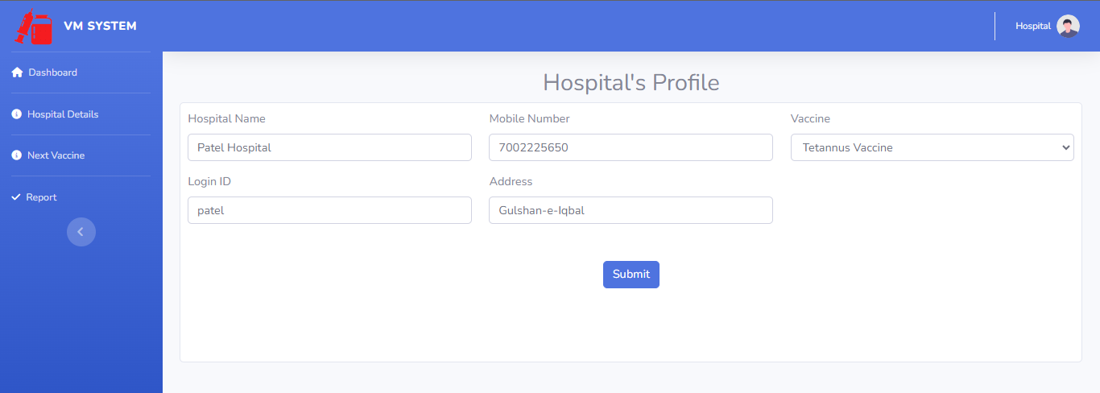

END

OF

DOCUMENTATION